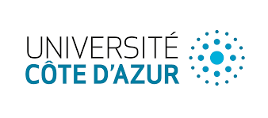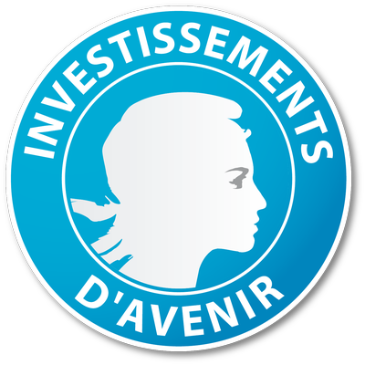

Call for applications for the UCA^{JEDI} Advanced Research Program
2021
Internal campaign

As part of its Advanced Research Program, Université Côte d'Azur is launching its 4th call for applications from researchers, faculty and artists for research grants aimed at supporting original and very high-level disciplinary research in all scientific and artistic fields represented at Université Côte d'Azur.

Who is this for?

This call is aimed at local active lecturers and researchers, having at least the status of maître de conférences or chargé de recherche (or equivalent), as well as artists on the basis of a research project in art and creation. Post-doctoral fellows and professors emeriti are therefore not eligible. Also excluded are artist residencies whose objective would be an artistic production that is not strongly linked to a research project.

The grants of the Advanced Research Program are intended for researchers, lecturers and artists from Université Côte d'Azur, to help them :
- establish ambitious international collaborations and develop an original research project, which should lead to an application for major national or international calls (IUF or ERC in particular). The improvement of a previously submitted but not selected project will also be considered and examined with particular attention,
OR
- establish ambitious international collaborations and develop an original research project within an existing Idex strategic program (see list in annex 4),
OR
- establish ambitious international collaborations and federate local competences around an original structuring research theme not identified in the list of the Idex strategic programs. The structuring potential of the theme must be demonstrated in the proposal.

What is the nature of the grant?

- Operating expenses 800€/month
- Salary for a maximum of 6 months of engineer CDD and/or teaching release for faculty.
The amount of the salary included in the scholarship will be the equivalent of a maximum of 6 months' salary for a research engineer. Its use will be negotiated on a case-by-case basis according to the needs of each project. It will also be possible to use it to compensate for a service discharge for faculty (in agreement with the employer).
In both cases, the duration of the award will be between 6 and 12 months.

Application procedures:

The application process will be carried out in two stages:

1. Submission, by the candidate of a file on the Nuxéo platform : https://nuxeo.univ-cotedazur.fr/nuxeo/nxdoc/default/e0dcc8ce-78df-4302-b860-6ddac5065365/view_documents in the form of a single file in PDF format, containing the documents listed in Appendix 1. This step will result in an initial selection and the establishment of a list of pre-selected candidates.

2. Oral interview by the members of the Program Committee (whose list will be communicated later) with the pre-selected candidates

Selection criteria:
The selection criteria will be as follows:
- Quality of the candidate's CV.
- Scientific and strategic interest of the project.
Candidates will select and highlight the elements of their CVs that demonstrate their scientific excellence.

Calendar:
Distribution of the call for applications: February 2021.
Deadline for the submission of applications on Nuxéo: May 31st, 2021.
Period of oral interviews: from the beginning of July 2021.
Publication of results: by mid-July,2021 at the latest.
Starting date of the projects : between Sept. 1st, 2021 and January 31st, 2022

------------------------------------------------------------------------------------------
APPENDIX 1: Preparation of the written file, which may be written in French or English
Reminder: All documents must be concatenated into a single file in PDF format

Curriculum vitae of no more than three pages in length according to the style sheet attached in Appendix 3, highlighting the elements that provide evidence of the candidate's excellence in relation to his or her years of experience. This 3-page CV will include a list of 5 candidate's major publications. Other publications may be included in an additional appendix.

Project description of no more than 5 pages according to the style sheet attached in Appendix 3, underlining its intrinsic scientific interest and its potential strategic interest for Université Côte d'Azur. The prospects for ERC or IUF applications opened by this project must be explained and argued as well as the expected impact of the project for these applications. The bibliographical references attached to the project may be the subject of an additional appendix, of a maximum of one page.

Application form: see Appendix 2.

Opinion of the director of the host laboratory.

APPENDIX 2: Application form
NAME, First name

Date of birth

Professional status

Laboratory or host team (followed by the director's signature)

Duration of the grant requested

Desired period for a possible teaching release

Name and affiliation of 5 scientists who may be consulted by the committee to deliver an opinion

APPENDIX 3: Template for the Curriculum Vitae and the project
The main objective of this model is to provide the font size, line spacing and margins that facilitate the reading and standardization of the file length.

Titre 1
Standard paragraph: Lorem ipsum dolor sit amet, consectetur adipiscing elit. Sed non risus. Suspendisse lectus tortor, dignissim sit amet, adipiscing nec, ultricies sed, dolor. Cras elementum ultrices diam.

Titre 2
Standard paragraph: Lorem ipsum dolor sit amet, consectetur adipiscing elit. Sed non risus. Suspendisse lectus tortor, dignissim sit amet, adipiscing nec, ultricies sed, dolor. Cras elementum ultrices diam. Maecenas ligula massa, varius a, semper congue, euismod non, mi. Proin porttitor, orci nec nonummy molestie, enim est eleifend mi, non fermentum diam nisl sit amet erat. Duis semper. Duis arcu massa, scelerisque vitae, consequat in, pretium a, enim. Pellentesque congue.

Titre 2
Standard paragraph
List:
- Item 1
- Item 2
- Item 3
APPENDIX 4 : List of Idex Strategic Programs

    - Quantum
    - Biocontrol
    - Astrophysics
    - Aging
    - Arts, Sciences, Culture
    - Tourism
    - Socio-environmental challenges
    - Risks in Mediterranean territory
    - Digital health

